REGISTRATION FORM
58TH ANNUAL MEETING
SATURDAY, SEPTEMBER 8, 2012
Grand Hyatt Washington, Washington DC

8th Annual David W. Kennedy Lectureship
Guest Lecturer: Donald C. Lanza, M.D.

Breakfast Symposium
“Innovations in Rhinology”

Resident’s & Fellows in Training Luncheon
(Resident’s/Fellows in Training only) 12:00pm – 1:00pm

Poster Presentation Wine & Cheese Reception – 5:30pm – 7:30pm

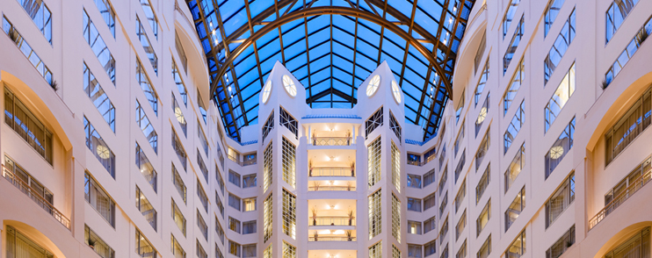
The 58th Annual Meeting of the American Rhinologic Society’s Headquarter hotel is the

Grand Hyatt Washington
Washington, DC

NEW!
FIRST TIME ATTENDEES…

Register by July 1st and join us for FREE!

(Register after 7/31 and we will give you a 50% discount on registration fees)

South Africa France Japan
(FREE MEETING REGISTRATION)
I WILL ATTEND. I HAVE COMPLETED THE INFORMATION REQUESTED.
I WILL REQUIRE DOCUMENTATION FOR VISA PURPOSES. EMAIL VERIFICATION LETTER TO: _______________________________________.
WELCOME GUEST COUNTRIES:

Breakfast Symposium (Included in registration fees)
Yes I will attend No, I am unable to attend

Resident’s & Fellows in Training Luncheon (Resident’s/Fellows in Training only) MUST REGISTER
Yes I will attend No, I am unable to attend

Poster Presentation Wine & Cheese Reception –
(Included in Registration Fees / MUST be Registered to Attend
Yes I will attend No, I am unable to attend
Please write legibly:
First Name: ______________________________ Last Name: _____________________________ Degree:_______________
Address_ _____________________________________________________________________________________________
City: ____________________________________________State: _______________________Zip Code: ________________
Tel: _______________________________________________Fax: ______________________________________________
Cell:__________________________________________ Country: ______________________________________________
Email: _______________________________________________________________________________________________
Early bird registration will be accepted by mail if postmarked by July 1, 2012. Registration received thereafter will be subject to full rate fees.
REGISTRATION: (All events listed above are included in the registration fee listed below)
Early Bird Registration: Fees prior to July 1, 2012 Registration Fees: After July 31, 2012
Medical Students: $25.00 Medical Students: $50.00
ARS Resident’s/Fellow in Training: $50.00 ARS Resident’s/Fellow in Training: $75.00
Non-ARS Resident: $75.00 Non-ARS Residents: $100.00
ARS Affiliate Member $125.00 ARS Affiliate Member: $150.00
ARS Member: $150.00 ARS Member: $175.00
ARS International Members: $150.00 ARS International Members: $175.00
Non-ARS Member: $225.00 Non-ARS Member: $250.00
Allied Health (RN, PA): $100.00 Allied Health (RN, PA): $125.00
Retired Members: $100.00 Retired Members: $100.00
Guest Country Attendee: FREE Guest Country Attendee: FREE
NEW First Time Attendee: FREE New First Time Attendee: $125.00
(50% discount)
PAYMENT: FAX REGISTRATION FORM TO: 845-986-1527 (CREDIT CARD PAYMENTS ONLY)
American Rhinologic Society, PO Box 495, Warwick, New York 10990 USA Tel: 845-988-1631 Fax: 845-986-1527

Credit Card Information: Master Card Visa American Express
Enclosed is a check made payable to the American Rhinologic Society – Fall 2012
Card Number: __________________________________________________________ Exp. Date: ______________
Billing Address: _________________________________________________________________________________
City: ________________________________State: ___________ Zip Code: __________________
Country:_____________ Authorized Signature: ______________________________________________________

